

COMPUTER SCIENCE DEPARTMENT

Advanced WEB Development

Theme: Project Documentation

Members:

Stalin Rivera Vega

Juliana Roman

Theo Rosero

Jerico Ruiz

NRC: 5119

Teacher: Jorge Edison Lascano

Date: Wednesday, August 2, 2022

Sangolquí-Ecuador

Index

List of pages that the “Finca Las Golondrinas” application will have. 3

Mockups interfaces. 3

UML 8

1. List of pages that the “Finca Las Golondrinas” application will have
2. After reviewing the requirements, it was determined that the website would have the following:

* Homepage

1. Information page.

2. Activities page.

3. Rooms page.

* User Page

1. Page to see services.

* Administrator page.

1. Bedrooms.
2. Activities page.
3. Rooms.
4. Mockups interfaces.

Layout of critical pages of the application

 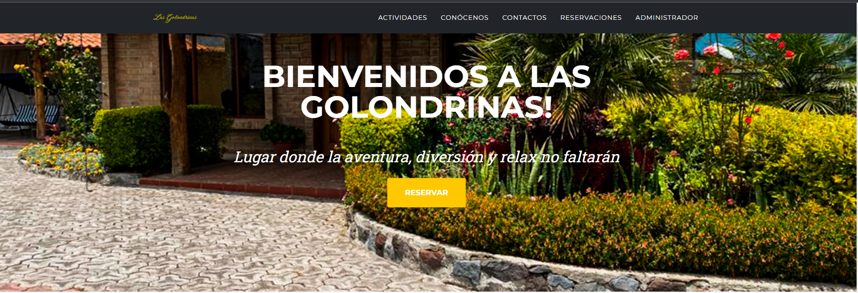

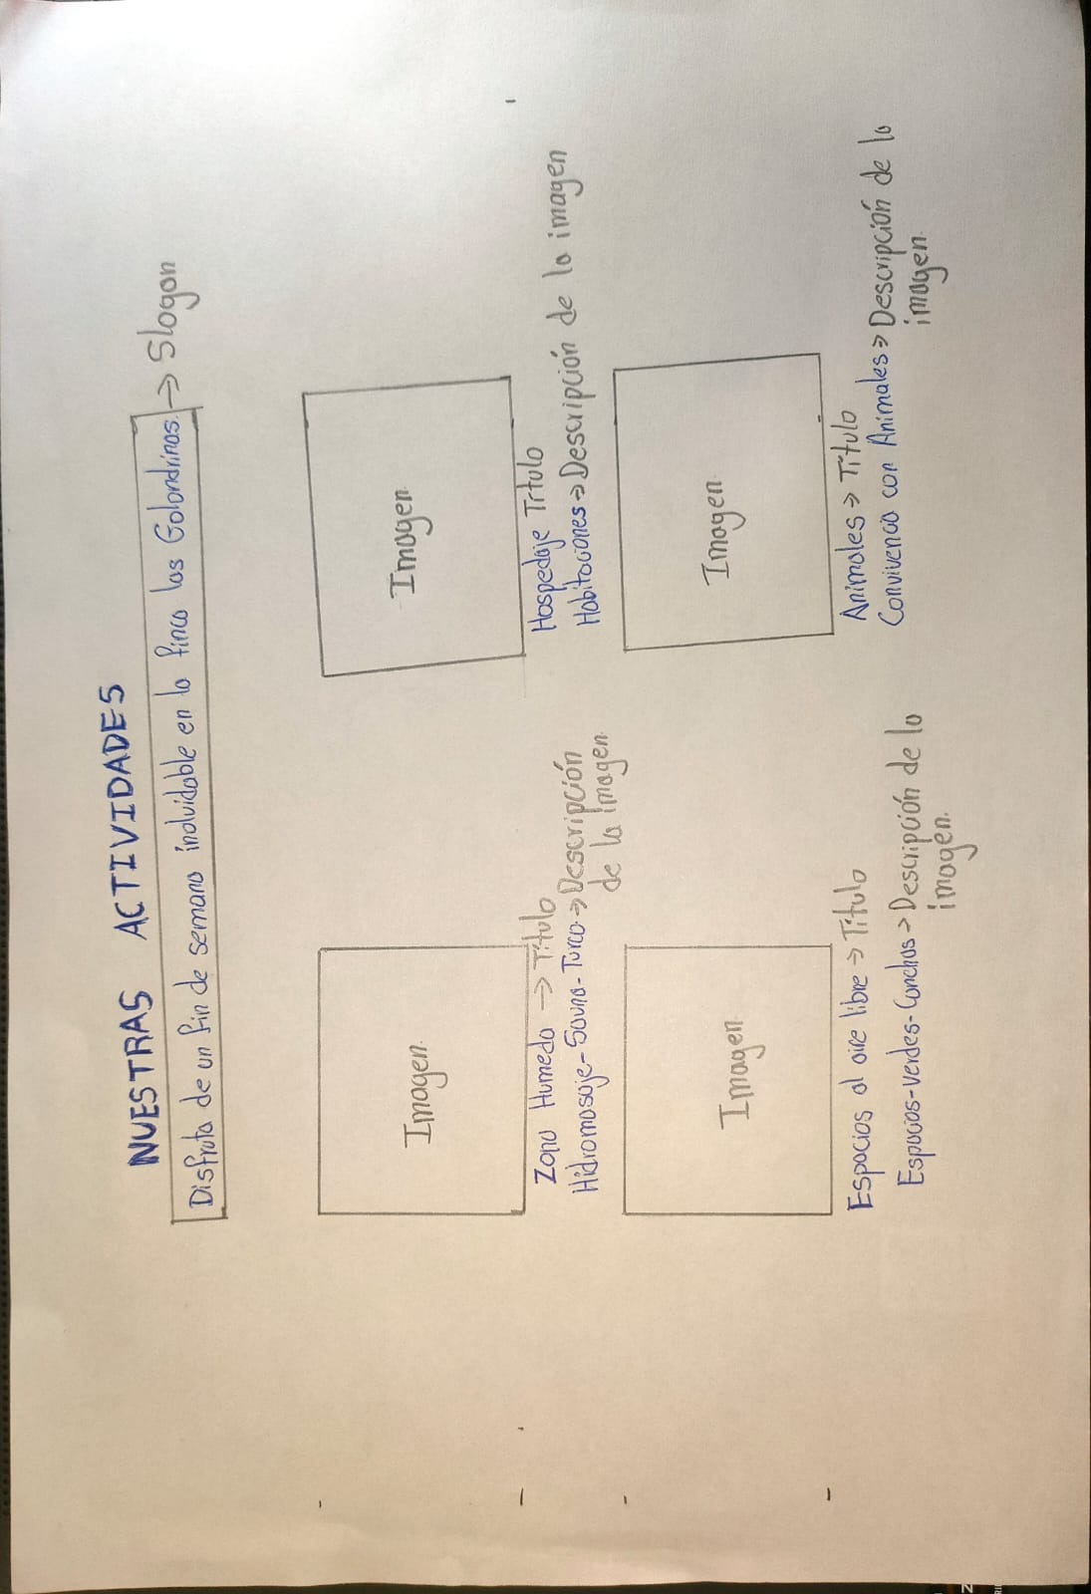

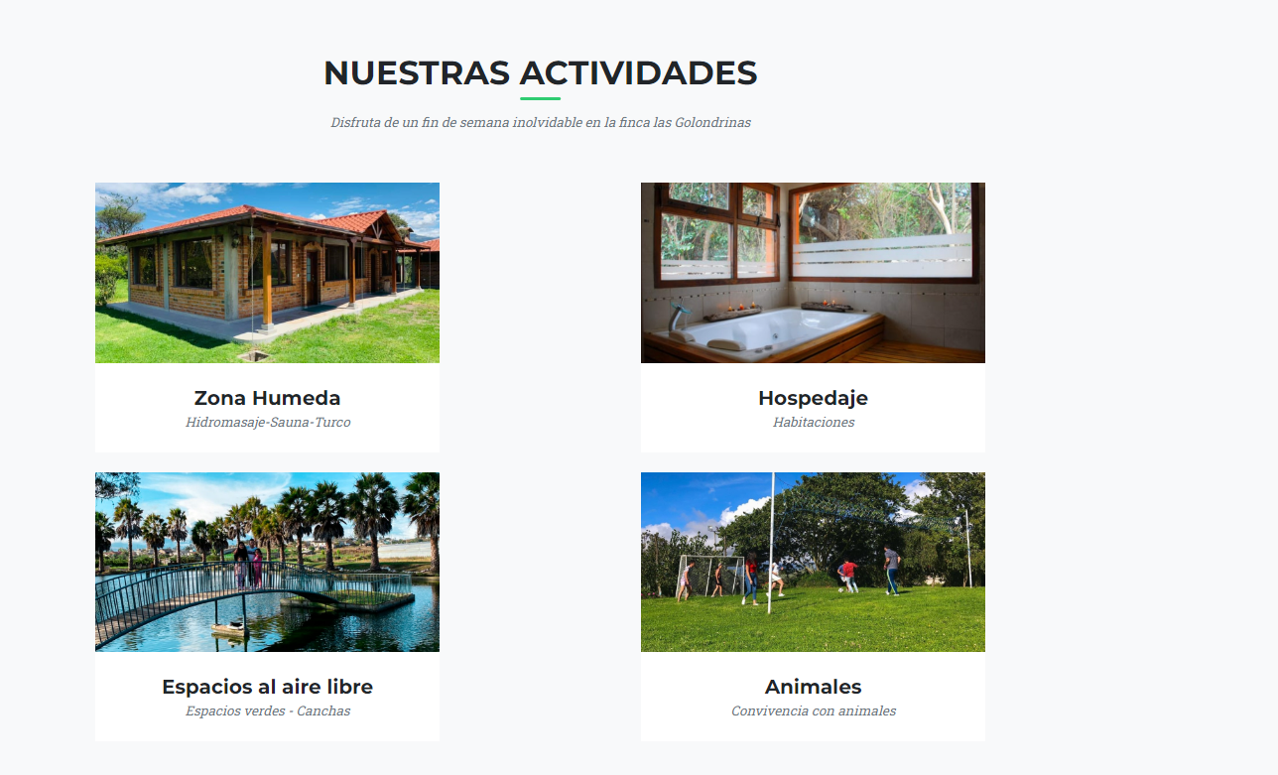

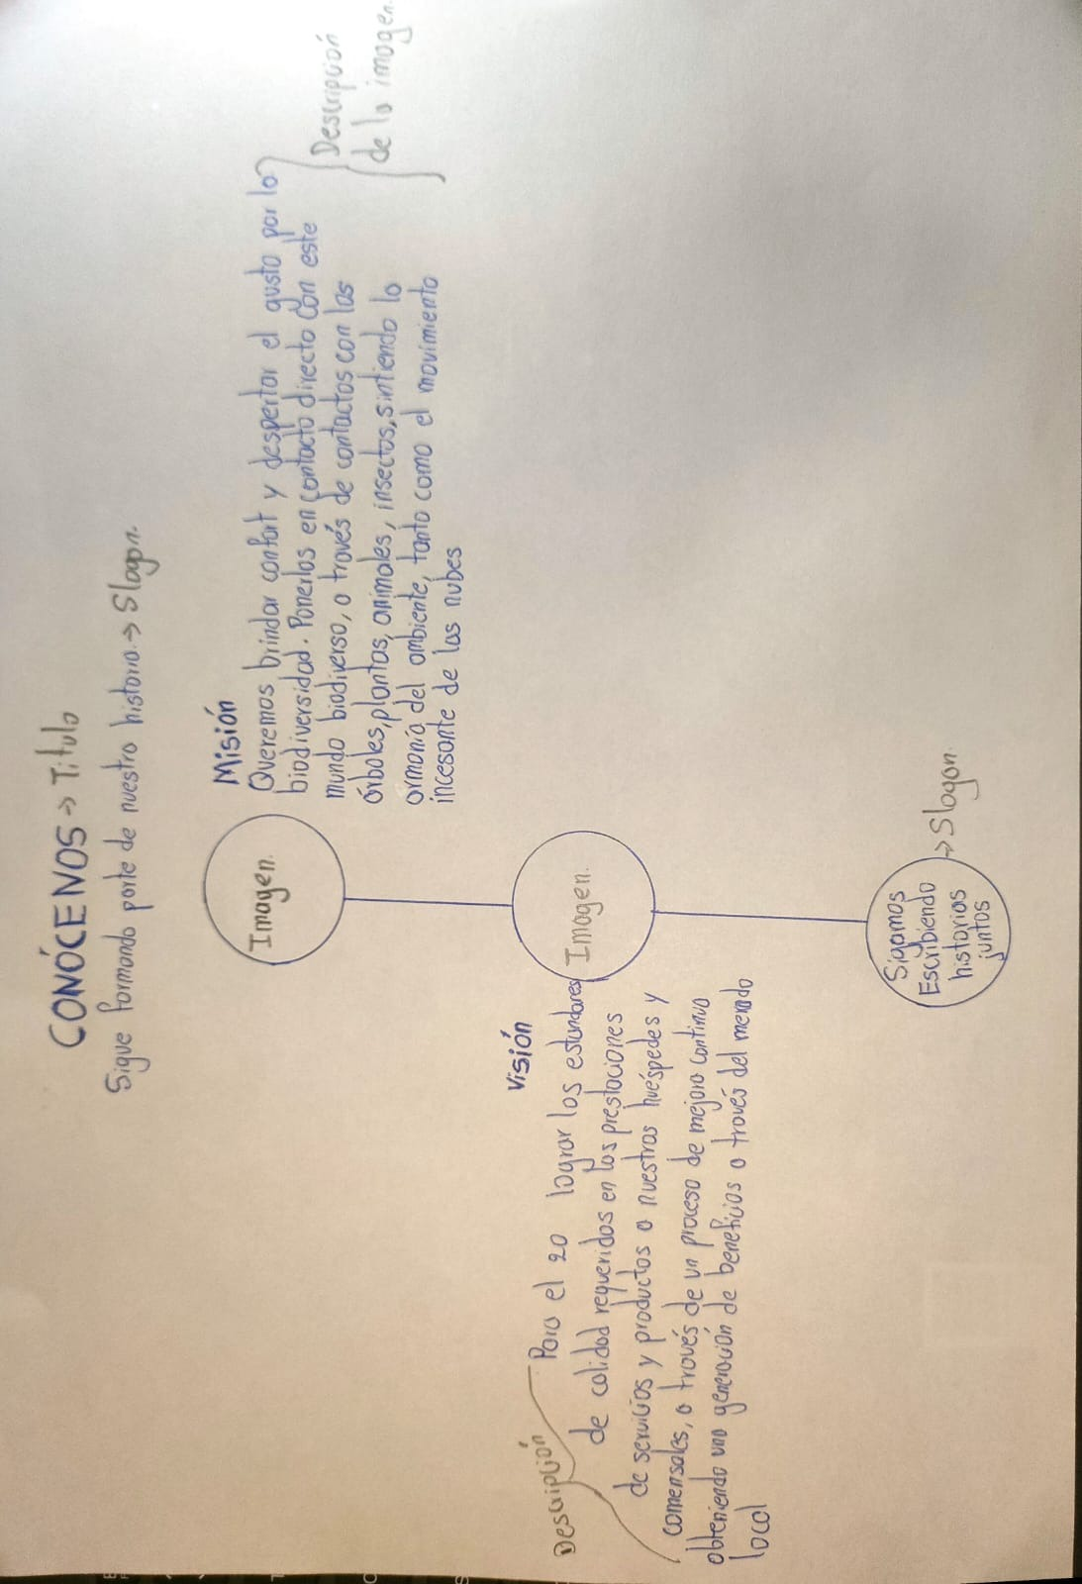

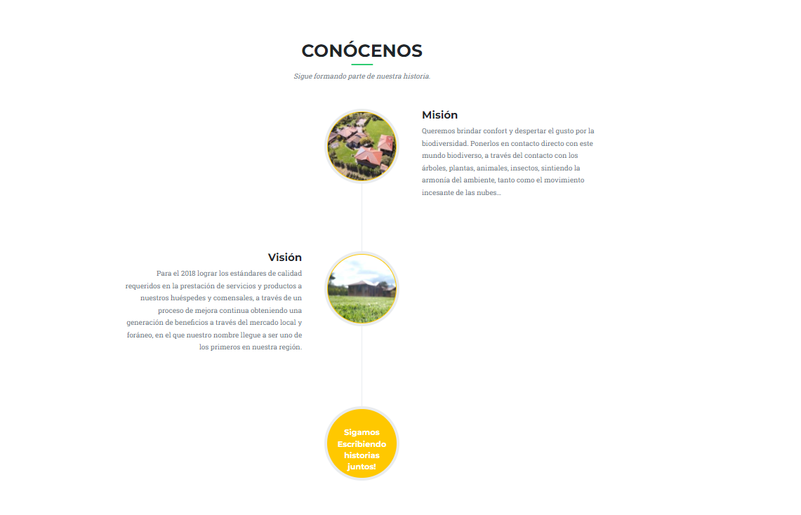 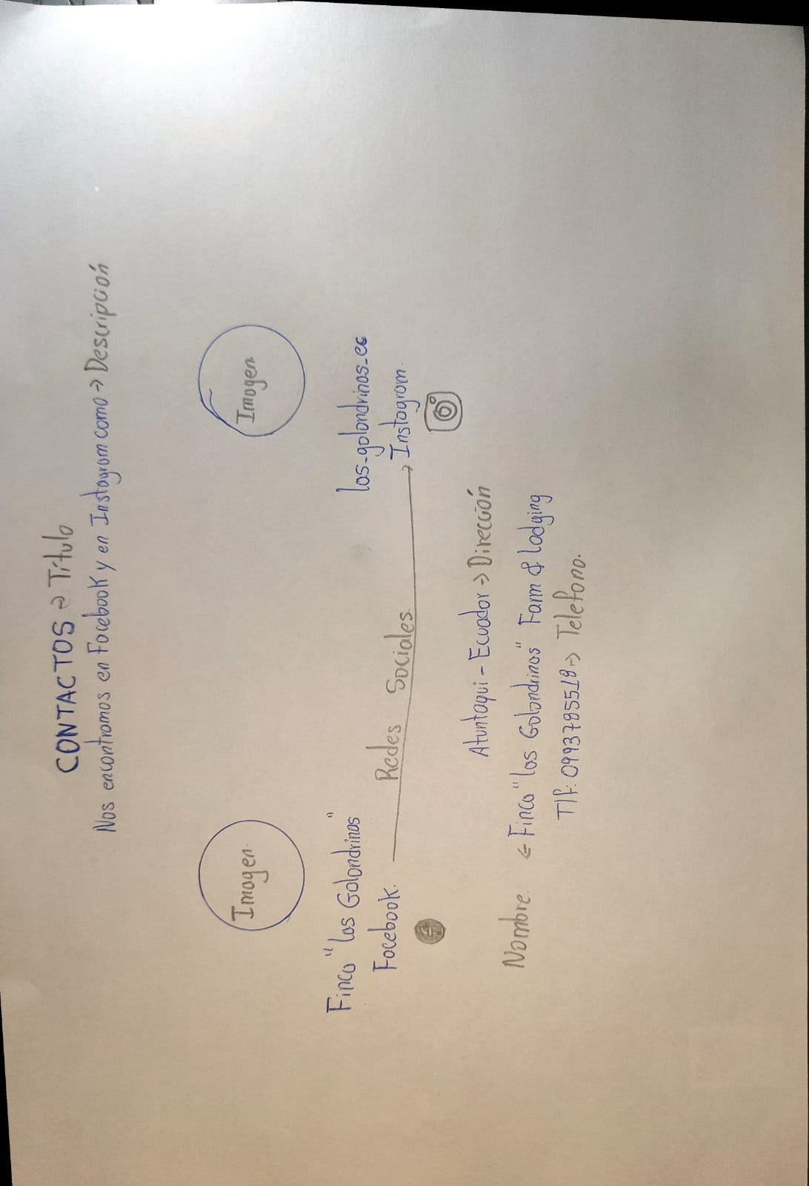 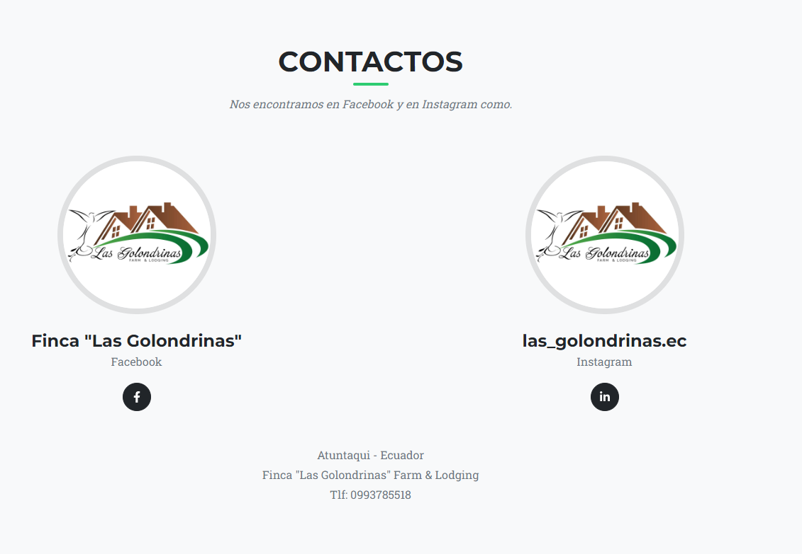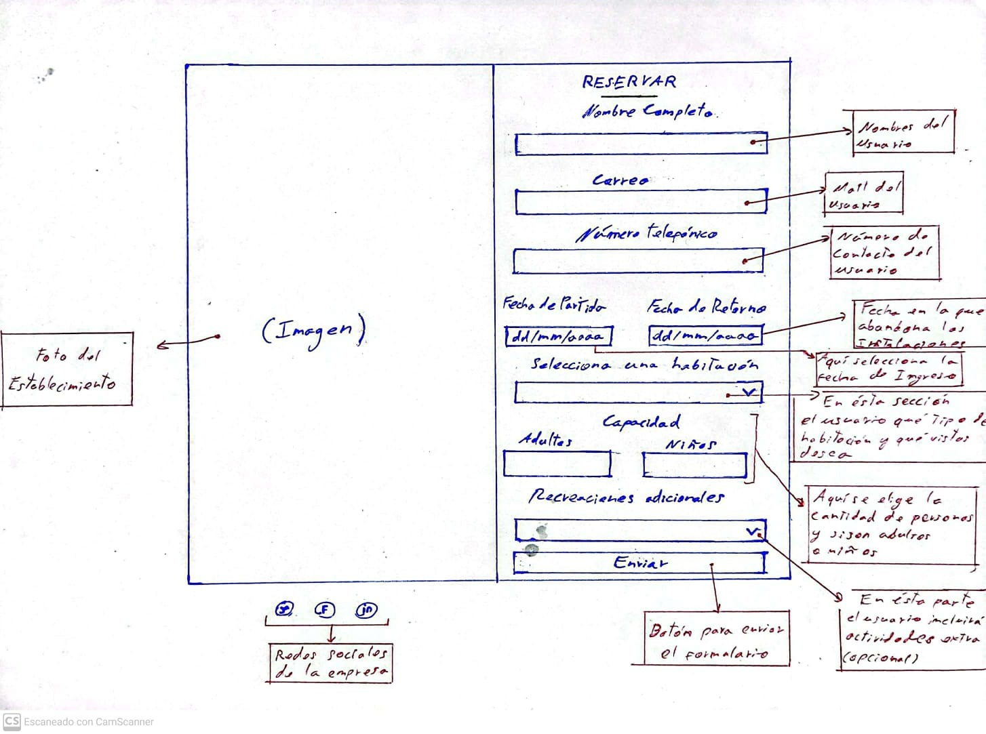 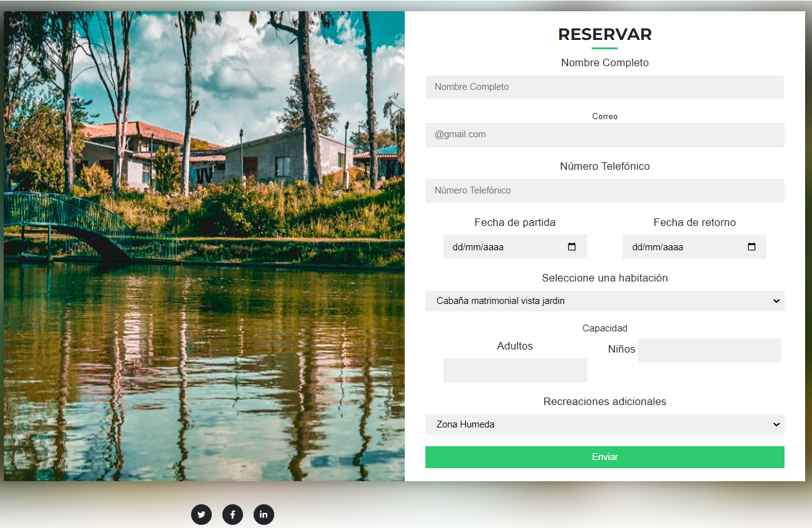

1. UML

